**Name: Muhammad Ahmad Raza Qadri**

**Intern ID: TN/IN02/PY/013**

**Task no:04**

**Question:**

1. **Fetch GitHub info of user and print repos of your account**

**Code:**

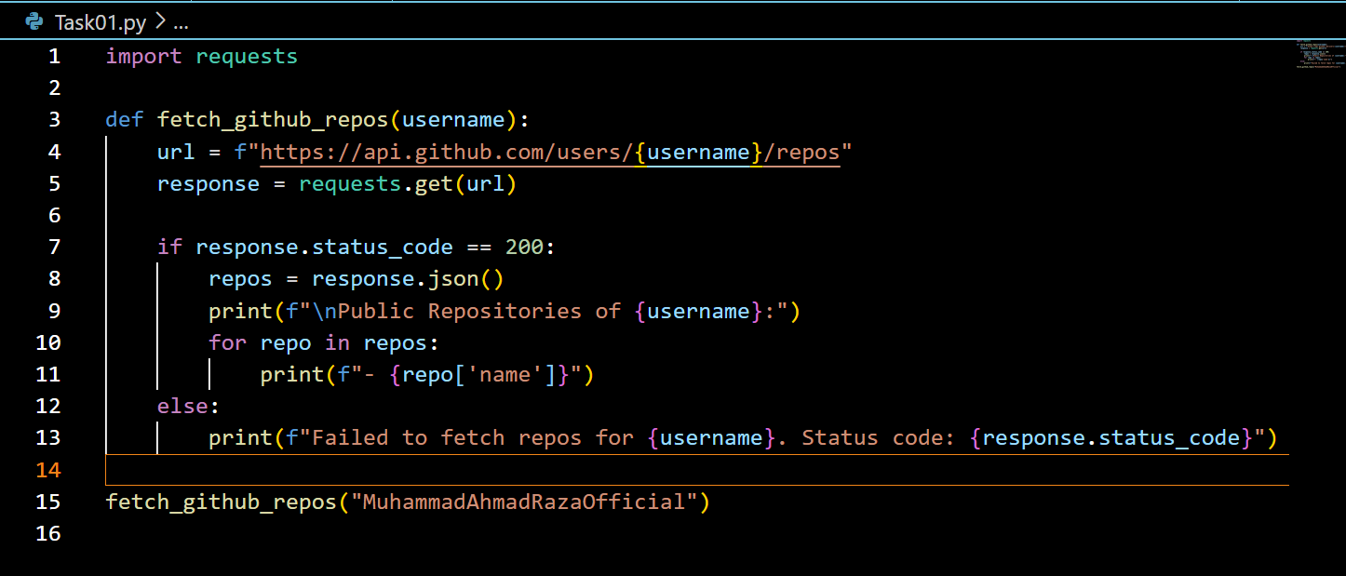

**Output**

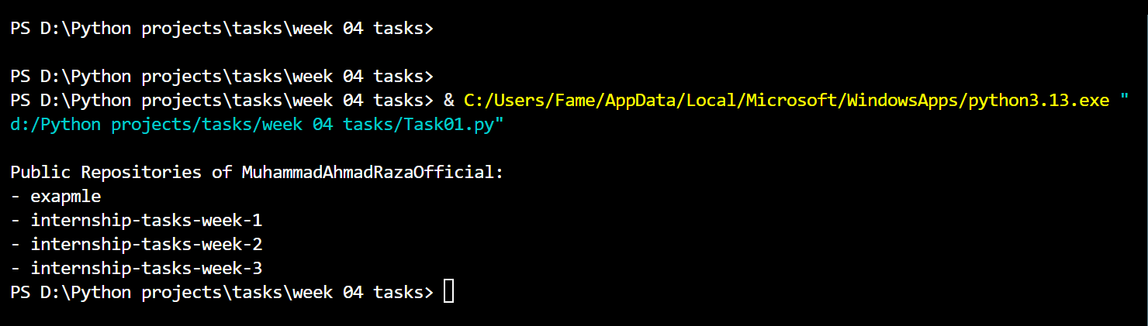

1. **Use joke api to fetch and print the jokes**

**Code:**

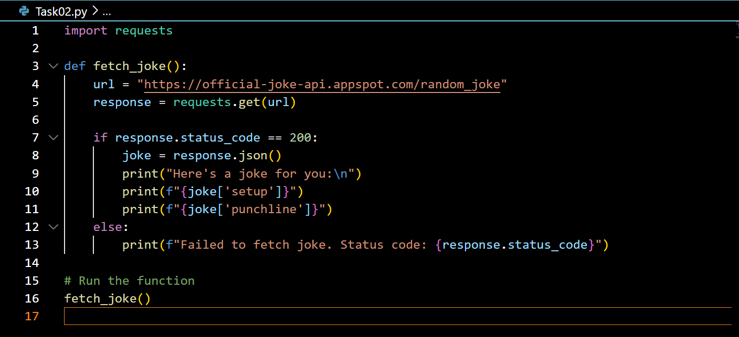

**Output:**

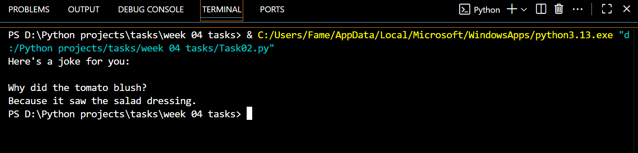

**Question:**

1. **Load students.csv that contain students data you have to clean it using pandas and then print the average marks for each subject of whole class.**

**Code:**

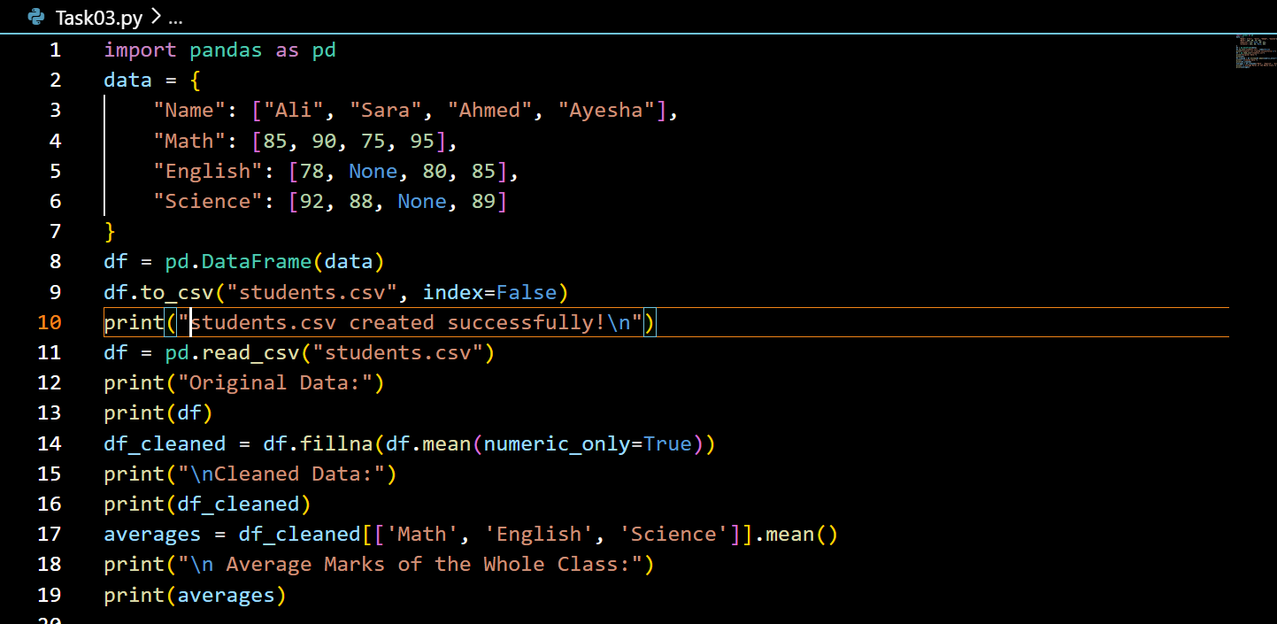

**Output:**

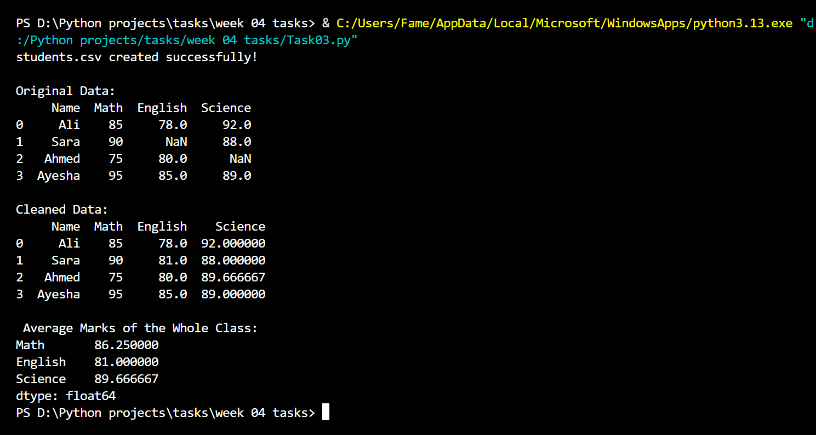

**Question:**

1. **Bar chart of marks per student from students.csv**

**Code:**

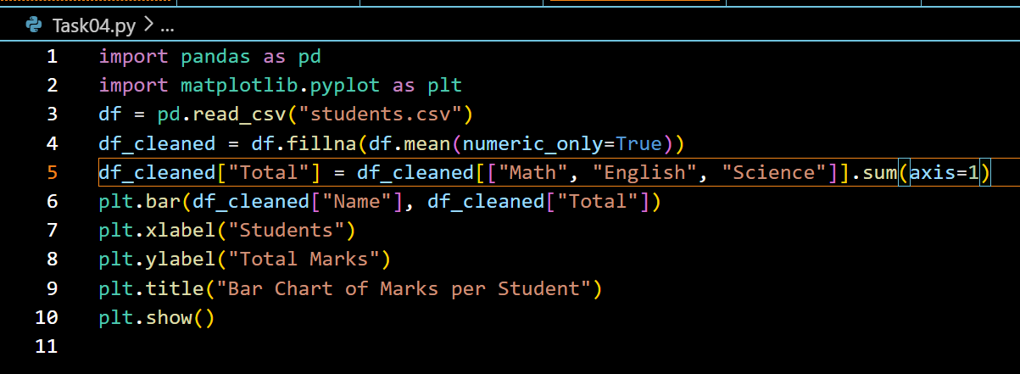

**Output:**

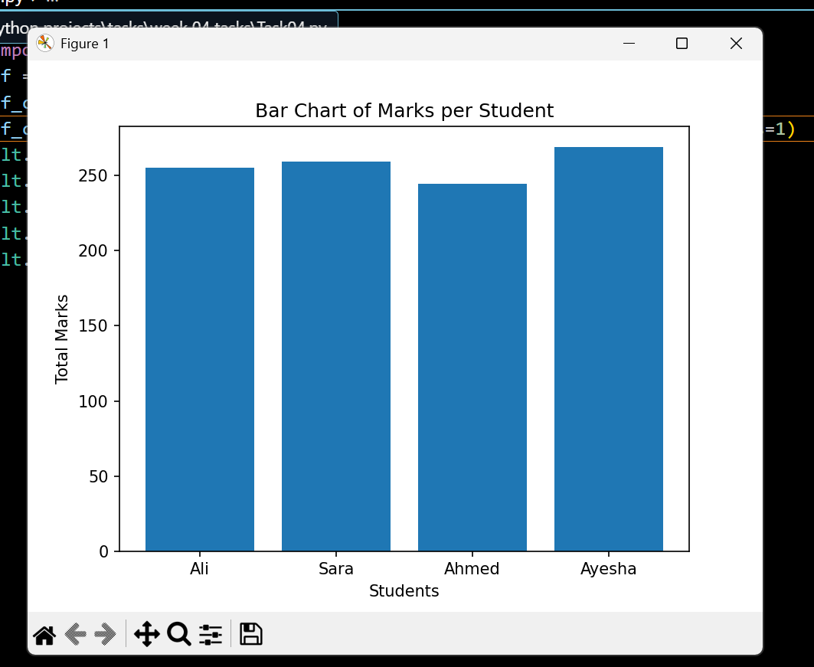

**2. Line chart monthly sales of company on dummy data.**

**Code:**

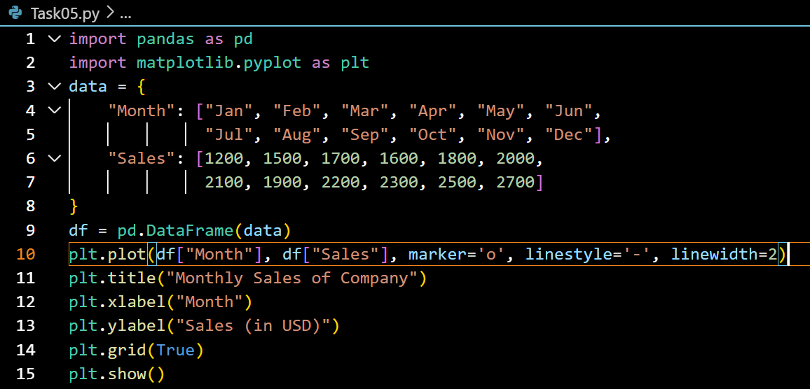

**Output:**

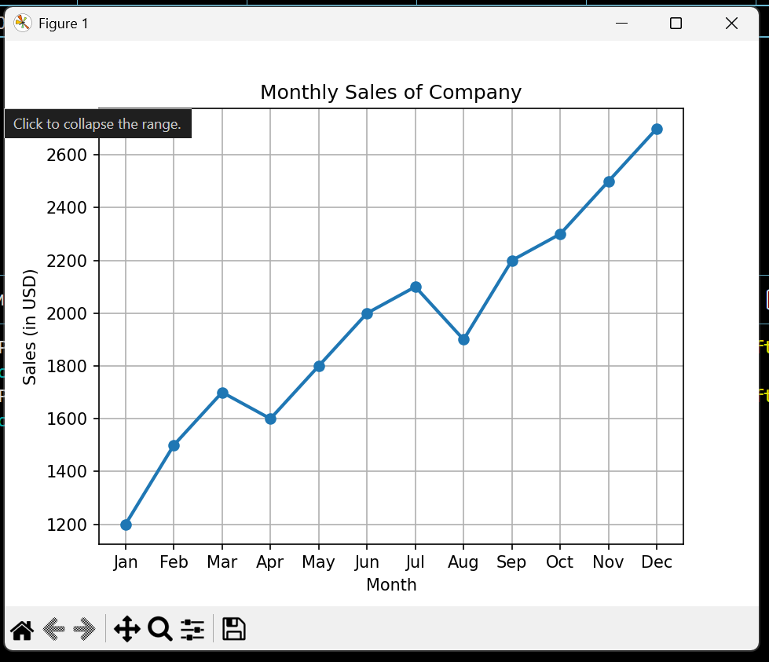

**Question:**

1. **Text analyzer character count app using gradio.**

**Code:**

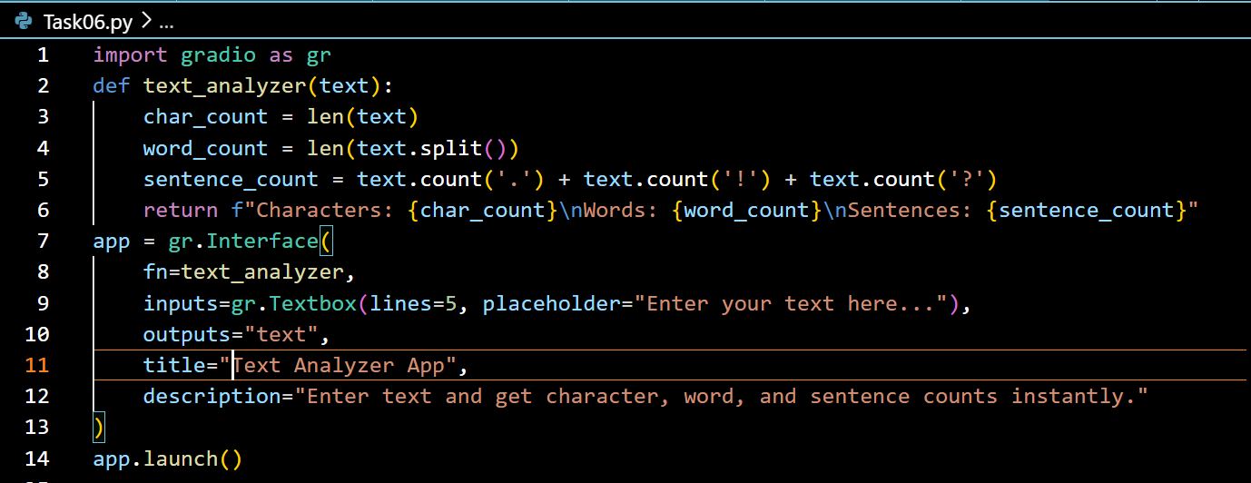

**Output:**

